Works

1. Fix a bug: During this process, I became familiar with how to add a new function, use Visual Studio for unit test, use postman for local test, submit PR, merge, CICD, online test and a series of pipeline processes, and also check and fill in C# and Knowledge of dependency injection, etc.

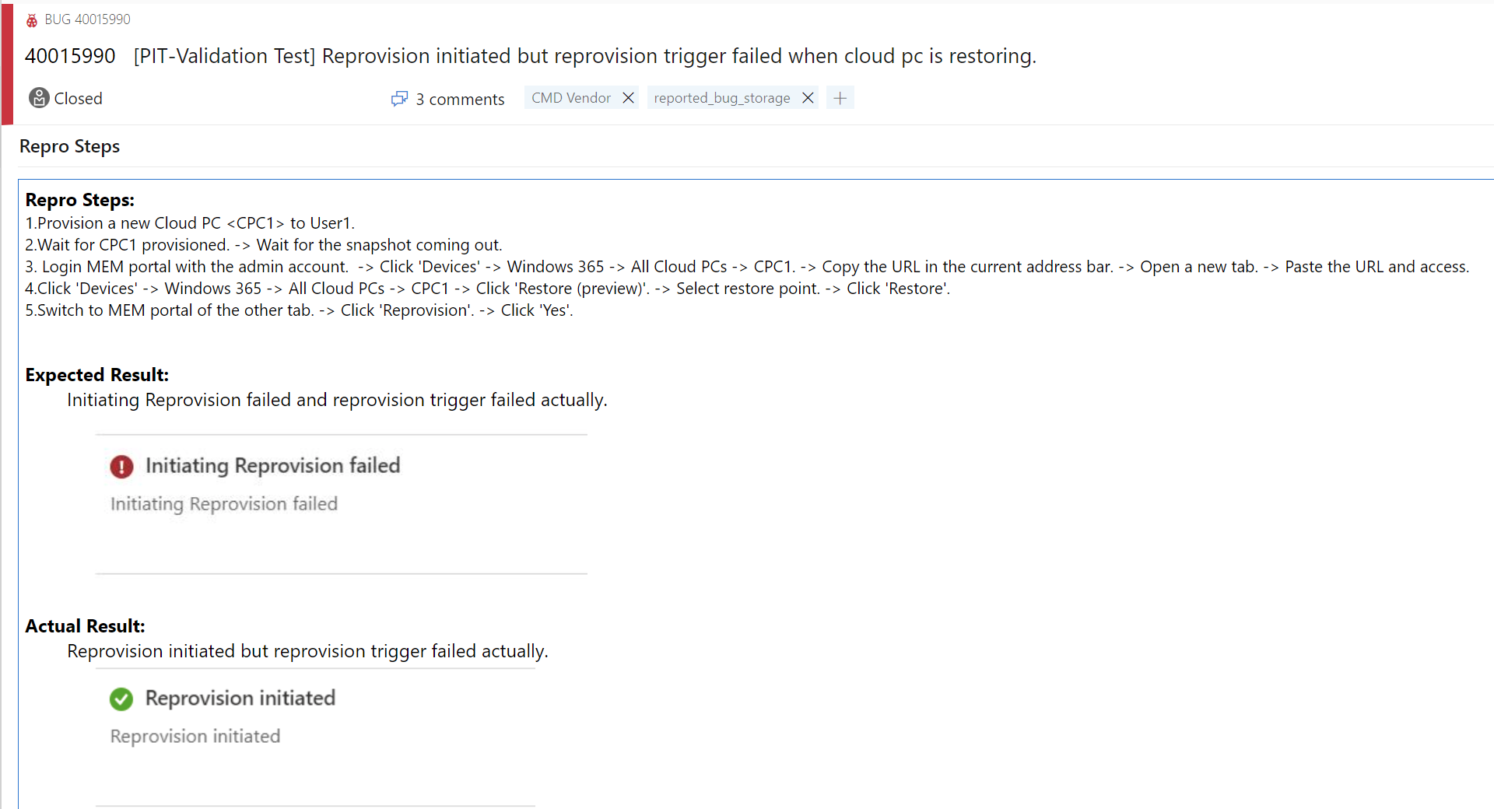

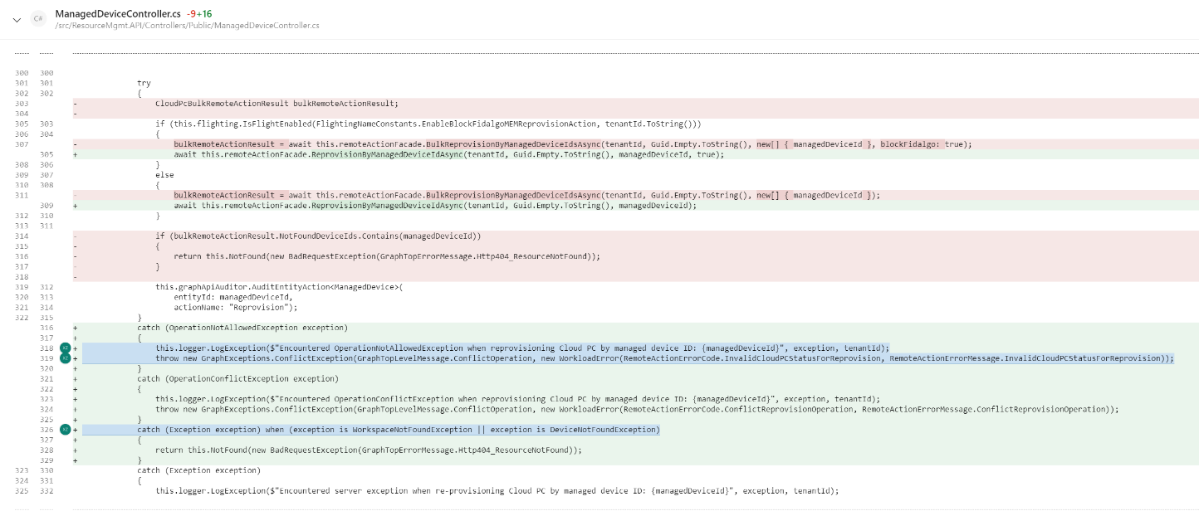

1. Knowledge sharing about Event Grid & Event Hub & Service Bus: 关于presentation的feedback



1. Automation: demo

1. Add OCE API: The need to modify multiple interdependent repos and access to modify the database gave me a better understanding of the code framework in the industry.

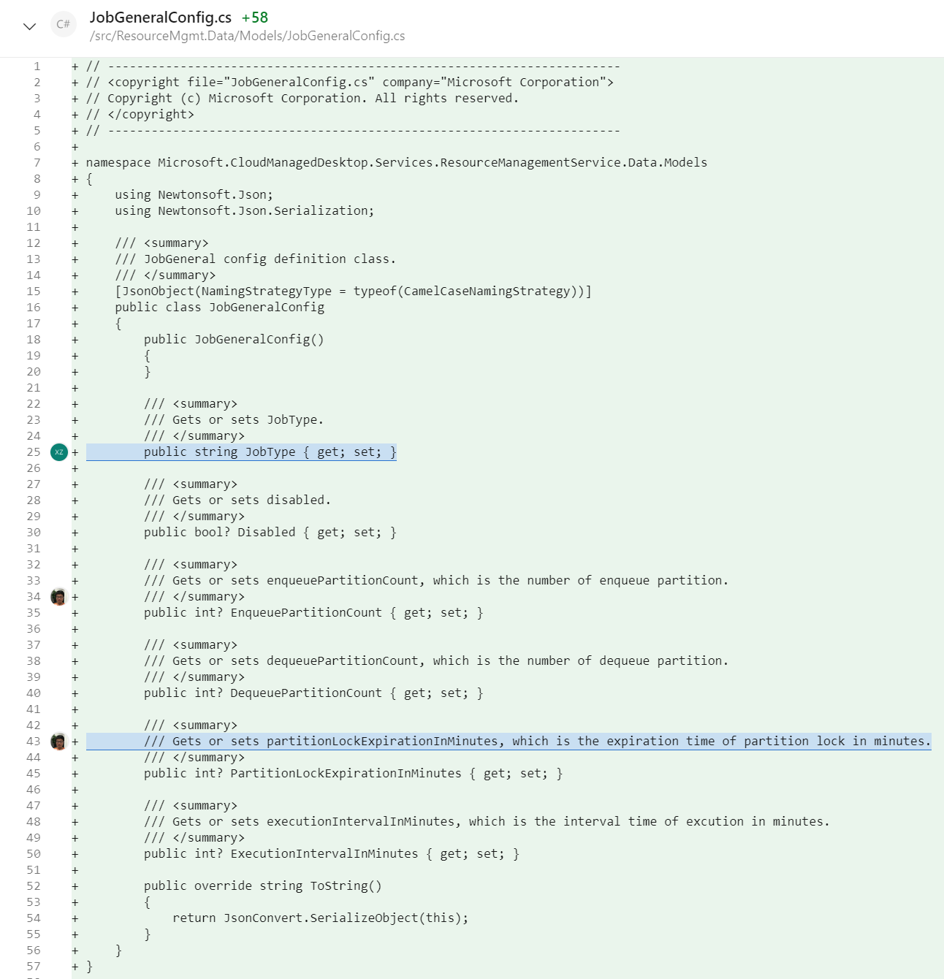

1. WorkItem time scheduler optimization

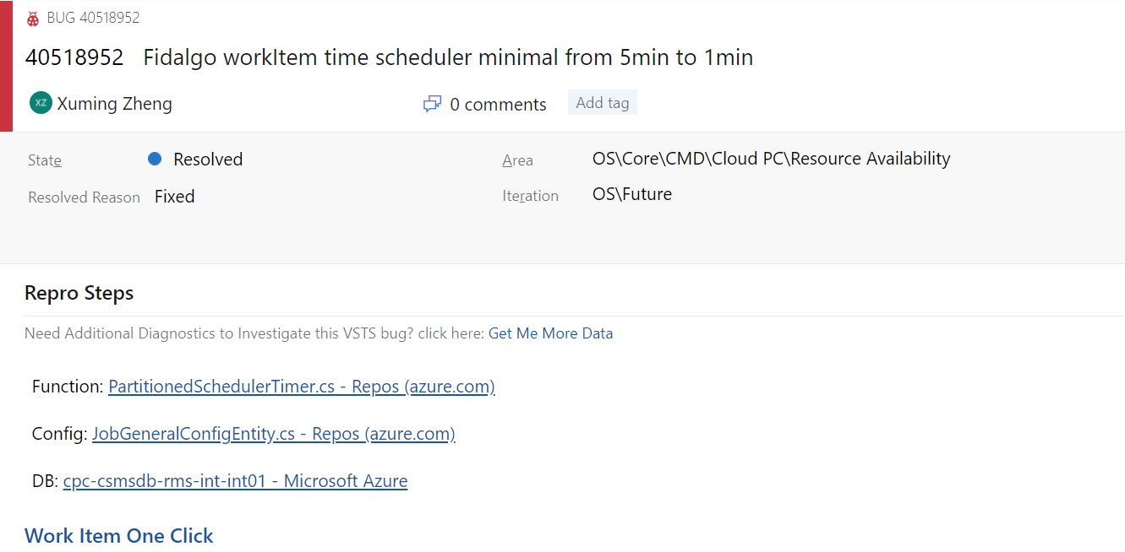

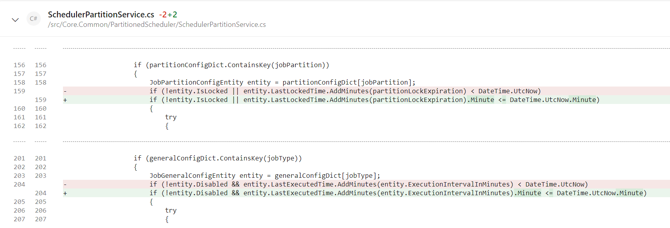

1. RemoteAction Monitor Improvement: Recently we found that many success rate drop incident is caused by error of customer manipulation, which do not need attention from OCE. So, we plan to add a dimension "ErrorCategory" to RemoteActionMetric so as to filter out customer error.

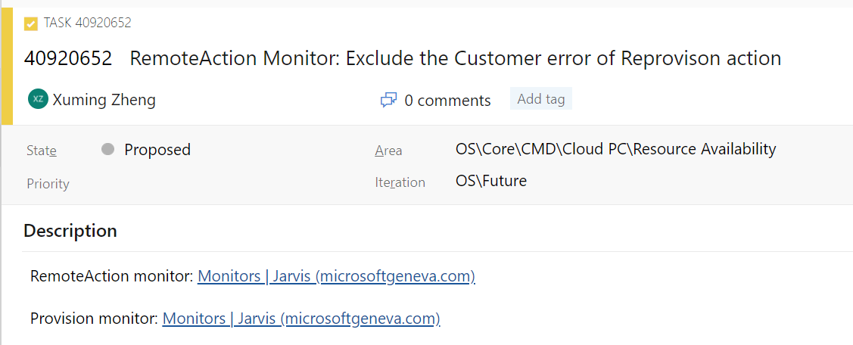

1. Exception handler for controllers:

